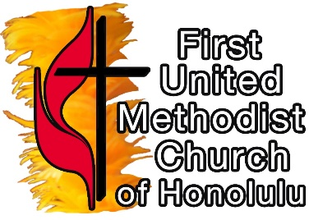
PROGRAM, PROJECTS, AND EDUCATION COMMITTEE (PP&E)
First United Methodist Church, Honolulu
Application for College Scholarship 2021-2022

Please Type or Print in Ink: Date:

Name: Age: Sex: ___Female ___Male

Mailing Address:

Telephone: Email Address:

RELATIONSHIP TO THE CHURCH:
- Are you a confirmed member of First United Methodist Church, Honolulu (First UMC)?

When were you confirmed?
OR
- Are you a regular attendee of First UMC (at least twice a month)?

How long have you been attending?
OR
- Do you have a parent or grandparent who is a member of First UMC?

Name of parent or grandparent:

Have you attended an average of once a quarter in the past year?

ACADEMIC RECORD:
What Grade Point Average (GPA) have you maintained? The minimum GPA is 2.5 to qualify for the scholarship. If you have a 3.5 GPA, you are eligible to receive a bonus amount. You must submit a transcript or report card (high school only) by July 1, 2021 (note – transcript must be in the office by then).

SCHOOL INFORMATION:

Are you a high school graduate? From what school?

What college or university will you attend this fall? What year or grade level?

What is your present major or concentration or degree program?

SERVICE TO THE CHURCH:
- Have you volunteered for at least 10 hours during that past year? In what ways? (please submit the log form or a confirmation letter from one of the pastors or program staff verifying your service).
- Have you volunteered for at least 25 hours during that past year? In what ways? (please submit the log form or a confirmation letter from one of the pastors or program staff verifying your service).

PERSONAL STATEMENT: Please submit a statement (no more than two pages) that gives an essence of who you are as you seek this scholarship: expressing your faith; your connection to First UMC; your career or future goals; your current studies; servanthood, etc.

ADDITIONAL INFORMATION:
- Two letters of recommendation must accompany this application: one must be from one of the pastors of First UMC; the other may be from a teacher, member of the church staff, member of the congregation, employer, etc.
- Submit your application digitally to office@firstumchonolulu.org or make 3 paper copies and submit to the church office or mail to the church: First UMC of Honolulu, 1020 S. Beretania Street, Honolulu, 96814; these will be distributed to members of the Scholarship Committee.
- Submit application no later than July 1, 2021 with your academic transcript or report card in the office or digitally time stamped July 1, 2021. Note that late applications will result in a reduction of possible awards.
- A final decision on your application will then be made by Program, Projects, and Evaluation Committee and you will be notified of action taken.

THANK YOU FOR YOUR APPLICATION! OUR PRAYERS FOR YOU!

